Instructions of the scripts:
- UI3.py : latest version. it provides a UI to input the parameters and saves into .ini files, which is for later usage of the code test for several files4
- Config.py : it generates a config file of only one file
- Config_for_multiple_files: it generates a config file for multiple files(.tif )
- Test for several files.py: it is only available to deal with six .tif files with specific names
- Test for several files2.py :the number of .tif files can be detected automatically
- Test for several files3.py: advanced version of Test for several files2.py, which uses the config file created by UI.py to input parameters
- Test for several files4.py: Latest version which allows for choosing specific files

Some files need to be edited for the file path including: Test for several files4.py and related versions
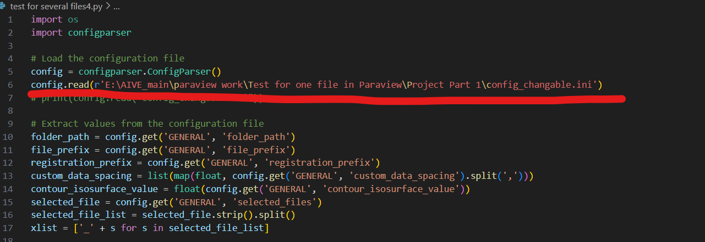
Replace it with your own path, this is where you save your config file
Something to remember is the difference for the file paths of Windows and Macs
For example the Path Separator
Windows: C:\Users\Alice\Documents\file.txt
Macs: /Users/Alice/Documents/file.txt
These codes can be run in windows but have not been applied in Macs

Steps:
- Run the UI3.py first and you can see a UI
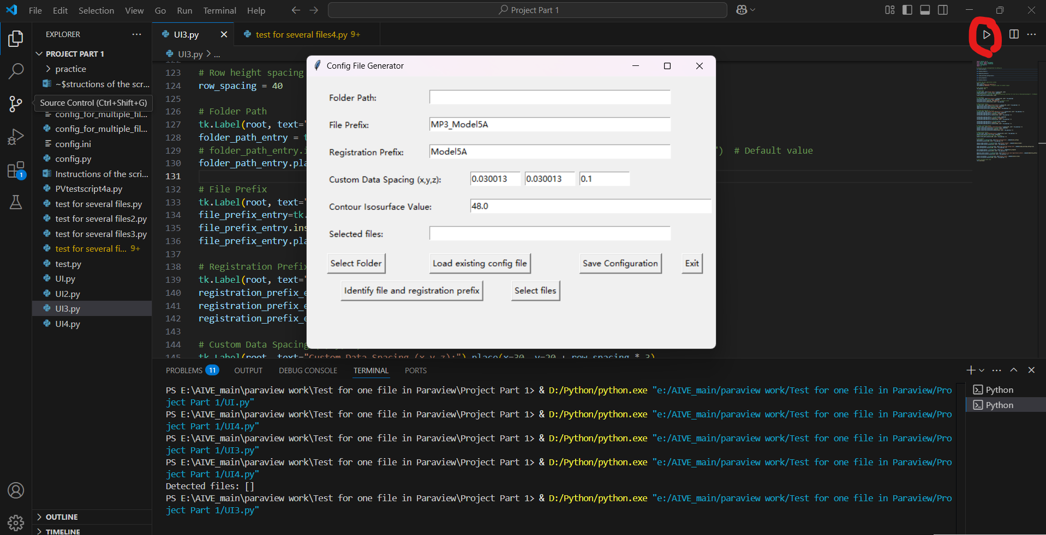

These are the parameters you need to fill in to create a config file for further usage. There are several options:
1.1 Load existing config files with these format (e.g. config.changable.ini)
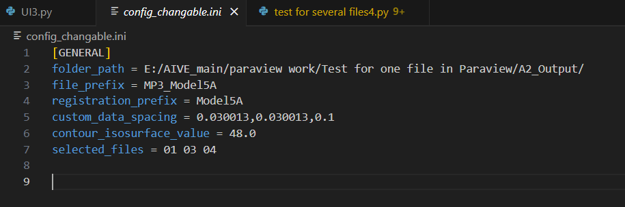

Click the button in the UI
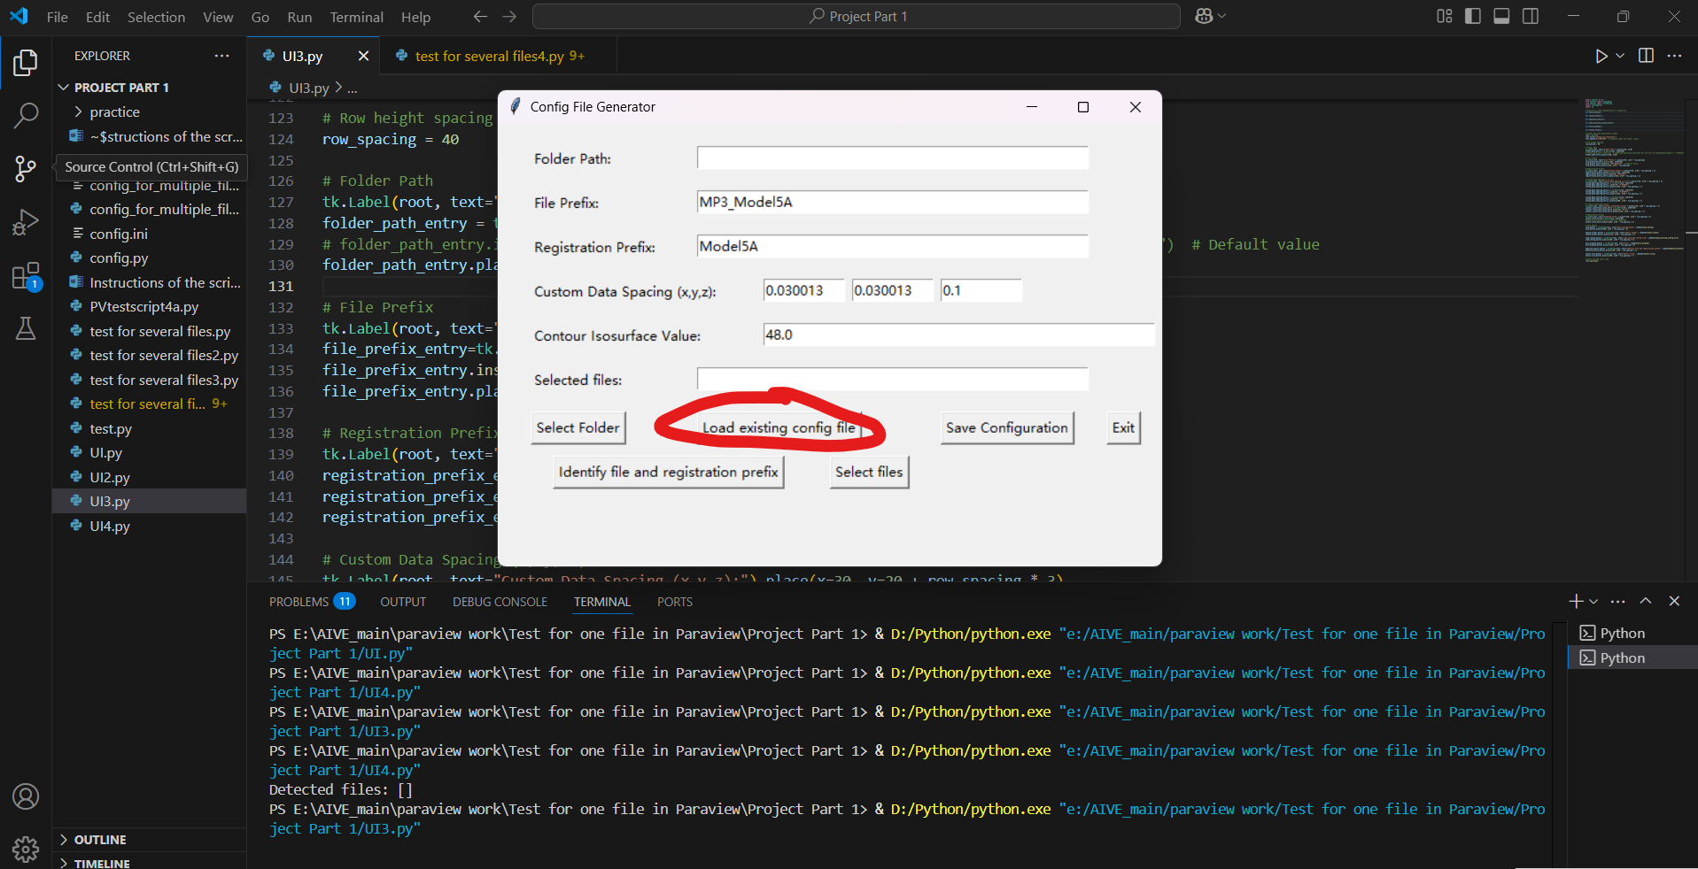
And get
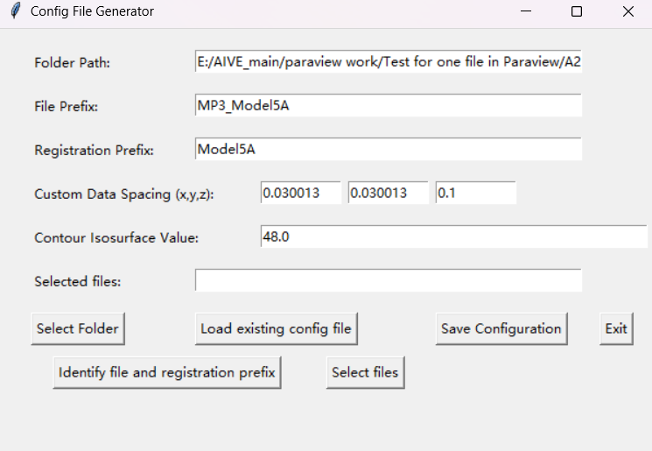
Then click ‘select files’ button to choose the files you want to process in Paraview at the same time

OR
  - Input the parameters respectively
Use the function ‘select Folder’ to find the folder path for .tif files (e.g. A2_output here)
Then use function ‘identify file and registration prefix’ for the second and third line by picking one sample .tif file
The fourth and fifth line have default values. You can change as you like.
Then click ‘select files’ button to choose the files you want to process in Paraview at the same time
The final will be like this
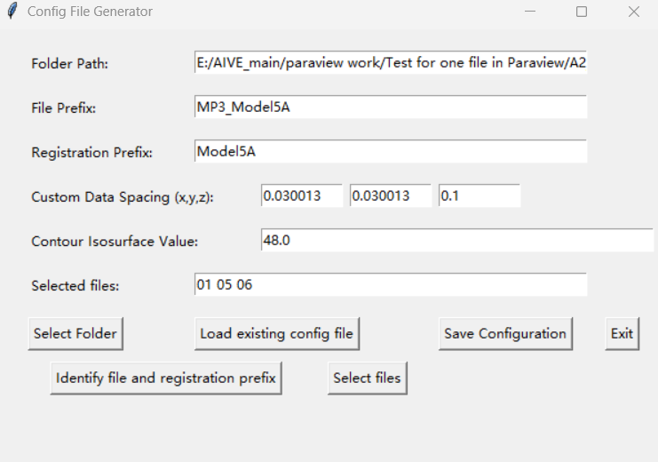

- Save as config file by clicking the ‘save configuration’, you can see a message box if the file is saved.
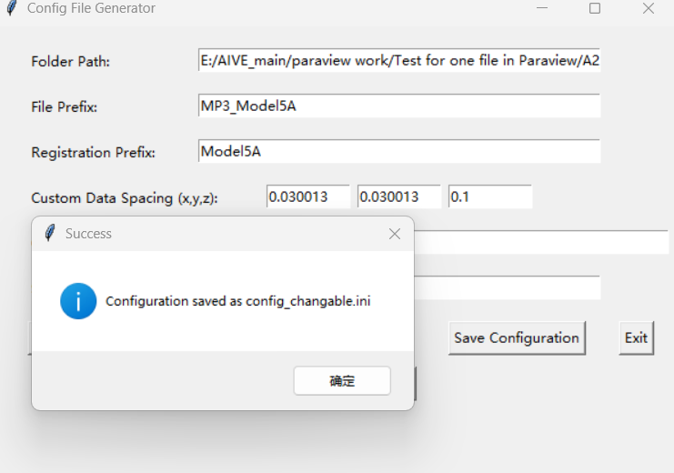

- Click ‘exit’ to close the UI
- Run the code ‘Test for several files4.py’ in Paraview
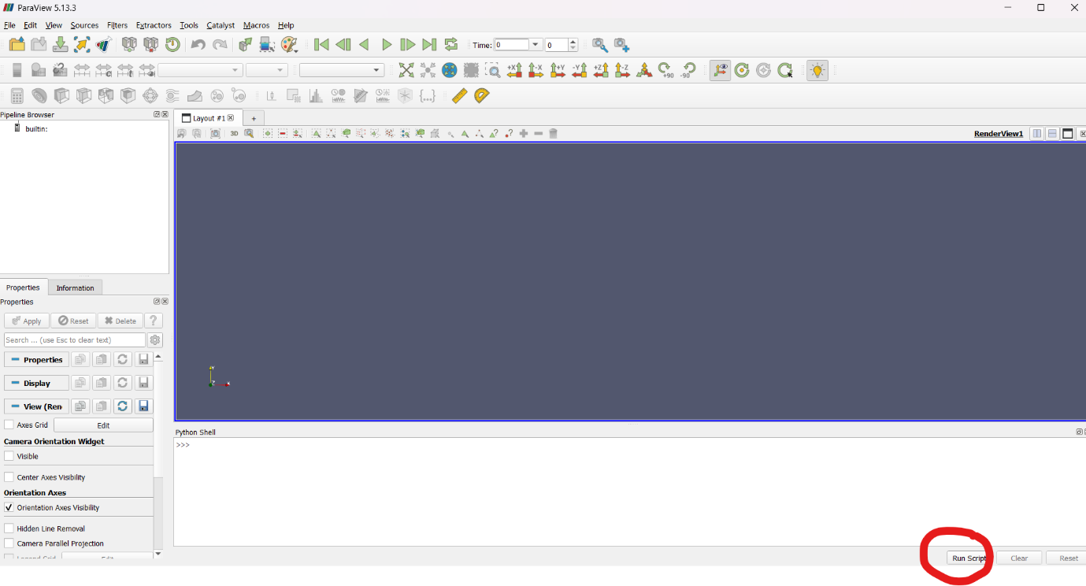
Then get
